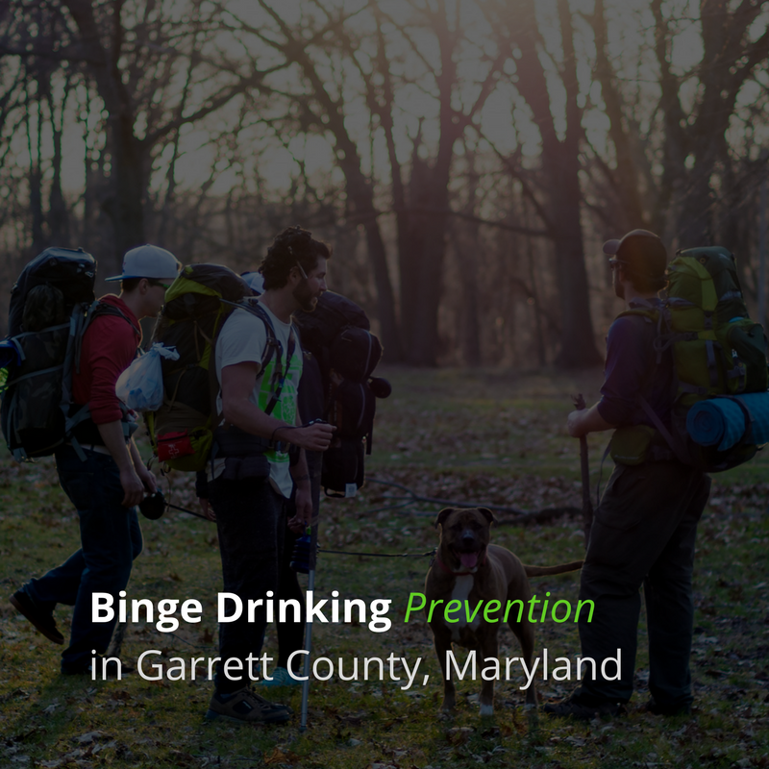

Maryland Strategic Prevention Framework 2
Community Media Toolkit
Revised July 18, 2017
Funding Partners
Supporting Prevention Efforts in Garrett County
- Maryland Behavioral Health Administration

Grant Administration
Garrett County Health Department Contacts
Brenda Sisler, MSPF2 Coordinator
301-334-7730
1025 Memorial Drive, Oakland Maryland, 21550
brenda.sisler@maryland.gov

Sandy Miller, ATOD Prevention Supervisor
301-334-7730
1025 Memorial Drive, Oakland Maryland, 21550
sandy.miller@maryland.gov

Purpose
Prevention Goals
MSPF’s priorities are to reduce the misuse of alcohol by youth and young adults in Maryland as measured by the following indicators:

- Reduce the number of youth, ages 12-20 years old, reporting past month alcohol use
- Reduce the number of young persons, ages 18-25 years old, reporting past month binge drinking

Garrett County Needs Assessment: Garrett County youth reported that alcohol is frequently provided by peers and friends (social access) and lack of exhibiting responsible drinking behaviors (individual factors).

Key Community Partners
Local Collaboration Opportunities

- Youth
- Parents
- Businesses
- Media
- Schools
- Youth serving organizations
- Religious or fraternal organizations
- Law Enforcement
- Civic and volunteer groups
- Health care professionals
- State, local or tribal agencies
- Youth focus groups
- Public school systems
- Other organizations involved in reducing substance abuse

Distribution Channels
Developing Campaign Awareness

- Newspaper
- Radio
- Facebook
- Twitter
- Email
- Website
- Movie Slides
- Instagram
- Incentives
- Banners for community events and towns
- Education: non-profit alcohol licensees and establishments, community groups, government.

Target Audience Demographics
Binge Drinking Prevention

18-25 year-old Garrett County youths are the target audiences for this campaign. While it is illegal to drink under 21 years of age, data shows that binge drinking is extremely high for this audience.
Existing Data Sets
Maryland Youth Adult Survey on Alcohol
https://health.maryland.gov
Maryland Department of Health
The cumulative responses from the past five surveys, covering an entire decade, provide trend data on health risk behaviors among Maryland’s youth.

GCHD Treatment Admissions
https://bha.health.maryland.gov/.../Documents/GarrettCounty.pdf
Strategic Plan for Alcohol and Drug Abuse compares the past 30 day alcohol and marijuana use with Maryland and US data.

Garrett County Health Department STD Data
garretthealth.org/sexually-transmitted-disease-std-clinic
This program provides STD prevention services, treatment, educational awareness, testing, and partner notification.
Health Services Cost Review Commission
www.hscrc.state.md.us

The Maryland automated accident reporting system (MAARS)
www.worldcat.org/title/maryland-automated-accident-reporting

Garrett County Alcohol and Drug Core Survey
bha.dhmh.maryland.gov/RESOURCES/Documents/LDAAC/GarrettCoLDAAC
Garrett County Drug Free Communities Coalition Strategic Plan for Alcohol and Drug Abuse

Garrett College Maryland Alcohol Survey
www.marylandcollaborative.org
The online measurement tool that was created specifically for the Maryland Collaborative, known as the Maryland College Alcohol Survey (MD-CAS), adapted measures from existing surveys and created new questions to assess dimensions of alcohol consumption and related problems that had not been previously measured. Excessive drinking is a complex problem, and MD-CAS is designed to capture the contributing factors and consequences of excessive alcohol use during
College.

Office of National Drug Control Policy (ONDCP) State and Local Information
http://www.whitehouse.gov/ondcp/state-map
The Office of National Drug Control Policy (ONDCP) coordinates the efforts of the federal government to reduce substance abuse in the United States. The State and Local Information page includes area specific statistics on drug use, prescription drug and drugged driving activities.

Substance Abuse and Mental Health Services Administration (SAMHSA)
http://www.samhsa.gov/statesinbrief
SAMHSA’s States in Brief site contains a brief overview of the substance abuse and mental health issues within a single state, including the prevalence of substance use and abuse, treatment resources, mental health indicators, and SAMHSA grant funding.

Youth Risk Behavior Survey from the Centers from Disease Control
http://www.cdc.gov/healthyyouth/yrbs/factsheets/index.htm#compare
The Youth Risk Behavior Survey (YRBS) provides data on health risk behaviors among 9th-12th grade students in the United States.

National Drug Intelligence Center
http://www.justice.gov/ndic
The NDIC is a center within the Department of Justice that provides strategic drug-related intelligence and training assistance to the drug control, public health, law enforcement, and intelligence communities of the United States in order to reduce the adverse effects of drug trafficking, drug abuse, and other drug-related criminal activity.

Maryland Statewide Epidemiological Outcomes Workgroup (SEOW):
http://www.pharmacy.umaryland.edu/programs/seow/
Maryland Department of Health

Behavioral Health Administration (BHA):
http://bha.dhmh.maryland.gov/Pages/Index.aspx

Maryland Strategic Prevention Framework (MSPF):
http://bha.dhmh.maryland.gov/pages/community-­‐prevention-­‐services.aspx

National Institute on Alcohol Abuse and Alcoholism
www.niaaa.nih.gov

National Institute on Drug Abuse
www.nida.nih.gov

National Institute of Mental Health
www.nimh.nih.gov

National Clearinghouse for Alcohol and Drug Information
www.ncadi.samhsa.gov

Tracking Measures
(See detailed measures in MSPF2 Strategic Plan)
- Data collection at public events
- Assessment of strengths and needs in existing alcohol control policies
- # of partners
- # and what type of media messages delivered
- Timeline of media campaign delivery
- # of impressions
- # of modes of dissemination
- % that changed drinking behavior due to kNOwdrinking.net campaign.
Campaign Messages
Promoting Community Wellness
Release Date | Short Message | Extended Message | Channels
Tentative - June 5, 2017  (pending BHA approval) | Individual Factors #1 Education  “THINK BAC” Know the Facts! | The ABC’s of BAC  - What is BAC?  - The amount of alcohol in a person’s body measured by the weight of the alcohol in a certain volume of blood  - What types of alcohol I drink affect my BAC?  - One shot of distilled spirits, or one 5- ounce glass of wine, or one 12-ounce can of beer  - What affects my BAC?  - The number of drinks. The more you drink, the higher your BAC.  - How fast you drink. When alcohol is consumed quickly, you will reach a higher BAC than when it is consumed over a longer period of time.  - Your gender.  - Women (typically) have more body fat than men and the alcohol enters the bloodstream more quickly so it takes less alcohol for women to reach .08 than it does most men.  - Your weight.  - The more you weigh, the more water is present in your body. This water dilutes the alcohol and lowers the BAC.  - Food in your stomach.  - Food slows the absorption of alcohol so 1 standard drink of alcohol on an empty stomach will have a different effect than the same drink on a full stomach.  - Mood/Fatigue  - Being overly tired or stressed or being in any extreme mood — happy, sad, angry –will be intensified by alcohol.  - Know your BAC – BAC Calculator | See distribution channels list above.
Tentative-June 5, 2017  (pending BHA approval) | Individual Factors #2 Action  “Practice Responsible Drinking Behaviors” | - Plan ahead (designated driver, etc…)  - Keep track by counting standard drinks*  - Eat before and while you are drinking  - Alternate alcoholic and non-alcohol drinks  - Avoid drinking games | See distribution channels list above.

*Note: All messages may have in small print, the message that it is illegal for anyone under the age of 21 to drink or possess alcohol. This is to be placed in small print above “Partially funded by BHA and SAMHSA.”

Community Materials
Campaign Deliverables
Release Date | Material | Message | Channels
June 5 Ad #1 | Radio Ads | Messages on responsible drinking behavior and BAC | Radio
June 5 (ongoing) | Social Media/Web | Messages on responsible drinking behavior and BAC | Facebook, Vineo, Instagram, Twitter
June 5 (ongoing) | kNOwDRINKING.org (Website) | Three content levels:  - Alcohol restrictions at community events  - Responsibly Drinking  - Data Blocks for Underage Drinking and Binge Drinking  Messages on responsible drinking behavior and BAC | kNOwDRINKING.org website
June 5 Ad #1 | Movie Slides | Messages on responsible drinking behavior and BAC | Movie theater
June 20 (ongoing at non-profit community events) | Billboards | Messages on responsible drinking behavior and BAC | Posted close to the non-profit community events where alcohol is sold & at the event.
June 5 (ongoing at non-profit community events) | Print Circulation | kNOwDRINKING.net | If funding allows
June 5 (ongoing at non-profit community events) | Aprons, Air Fresheners, Banner Pens, etc… | kNOwDRINKING.net | Given to nonprofit alcohol related organizations that are listed in the events section below. If funding allows.

Events
Campaign Promotions
Date | Location | Event Description | Key Partners
September 2017 | Deep Creek Volunteer Fire Dept. McHenry, MD | Crabfest | Deep Creek Volunteer Fire Dept.
September 2017 | Grantsville VFD, Grantsville, MD | Gun and Cash Bash | Grantsville VFD
October 2017 | Friendsville VFD, Friendsville, MD | Gun and Cash Bash | Friendsville VFD
October 2017 | Oakland VFD, Oakland, MD | Oktoberfest | Oakland VFD
October 2017 | Oakland VFD, Oakland, MD | Arm Wrestling Tournament | Oakland VFD
November 2017 | Eastern GC FVD, Finzel, MD | Gun Bash | Eastern GC FVD
February 2018 | Friendsville VFD, Friendsville, MD | Gun Bash | Friendsville VFD
February 2018 | Uno’s Restaurant, Deep Creek Lake | Deep Creek Dunk | Maryland State Police Special Olympics
February 2018 | ? | Fundraiser Scholarship Dinner | Oakland/Mt. Lake Park Lions Club
March 2018 | Eastern GC FVD, Finzel, MD | Gun, Cash, and 4x4 Bash | Eastern GC FVD
March 2018 | Kitzmiller VFD, Kitzmiller, MD | Cash Bash | Elks Lodge, Oakland, MD
March 2018 | Oakland VFD, Oakland, MD | Mega Bash | Oakland VFD
April 2018 | McHenry, MD | Gun and Cash Bash | Deep Creek VFD
April 2018 | Grantsville VFD, Grantsville, MD | Gun and Cash Bash | Grantsville VFD
May 2018 | Deer Park VFD, Deer Park, MD | Gun Bash | Deer Park VFD
June 2018 | Friendsville Town Park, Friendsville, MD | Celtic Festival | Friendsville FVD, Ken’s Irish Pub, Friendsville Town Halli
The dates and time for the non-profit events will be determined as they are scheduled. The location will be decided upon by the DFCC and the Action Team to prevent underage and binge drinking.
Sample Media
Collateral Design Examples
These examples and simplified style guide are examples of content promoting the messages within this toolkit.
#62CC23
Strong Green
All of the Garrett County Health Department’s alcohol awareness campaigns currently utilize are being converted to use the color Strong Green (#62CC23) and the Open Sans font family. Universal use of a single color and branding mechanism increases awareness, aids in message recognition, and helps to efficiently promote campaigns with longevity of message impact in focus.

Aa Aa Aa
ABCDEFGHIJKLMNOPQRSTUVWXYZ
abcdefghijklmnopqrstuvwxyz
123456789 (!@#$%^&*?;:’”)

These examples and simplified style guide are examples of content promoting the messages within this toolkit.
