Fitness Assessment
Name: _________________________________________ Age: __________
Physiology |  |  |  | Body Measurement |  |  |  | Cardio-vascular  Endurance
Date |  |  |  | Date
Resting blood pressure  (<120/80) |  |  |  | Height  (ft./in.) |  |  |  | 1/2 Mile walk/run  (time in min. & sec.)
 |  |  |  | Weight  (pounds) |  |  |  | Date: | Date: | Date:
Resting heart rate  (60-120 bpm) |  |  |  | BMI
 |  |  |  | % Body Fat
Blood Pressure  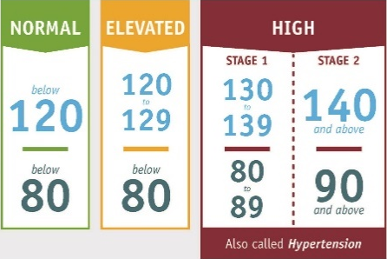  OR  OR  AND  AND  Lifestyle changes can lead to big improvements in your blood pressure and reduce your risk for heart problems:  - Losing weight  - Eating heart healthy  - Getting regular physical activity |  |  | What is BMI?  BMI stands for Body Mass Index, and is calculated using your weight and height, and is then used to find the corresponding BMI-for-age percentile for your age and sex. It is a quick way to tell if you are underweight, normal weight, overweight or obese.  What is body fat percentage?  Body fat includes both essential and stored body fat. Essential body fat is necessary to maintain life and reproductive functions. The body fat percentage is a measure of fitness level, since it is the only body measurement which directly calculates a person’s relative body composition without regard to height or weight.  What are the risks? Adolescent obesity can have a harmful effect on the body in various ways: increased risk of type 2 diabetes; depression, behavioral problems and issues in school; low self-esteem; impaired social, physical and emotional functioning; and high blood pressure and high cholesterol which are risk factors for heart disease. Obese adolescents are more likely to become obese adults which is associated with a number of serious health conditions including heart disease, diabetes, and some cancers. For more information, visit www.cdc.gov/healthyweight/bmi/calculator.html and click on ‘The Health Effects of Overweight and Obesity’ in the left column or talk to your healthcare provider.  Healthy % Body Fat for 7-12 year olds  Females 15-28%  Males 13-22%  To view a BMI-for-age Percentile Growth Chart, visit www.cdc.gov/healthyweight/bmi/calculator.html  BMI % Weight Status  < 5 Underweight  5 – 85 Normal or Healthy Weight  85 – 95 Overweight  > 95 Obese  * Individuals with greater muscle mass or larger bones will  have higher BMI’s.

