Bethel Outdoors
A place to be
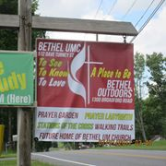
1300 Broadford road
An outreach of Bethel United Methodist church
512 Dave Turney street
Mtn Lake Park MD
301-334-4488
Pastor Chris Duckworth
The Pastor will be on sight most
Thursdays 8-9:30am followed by bible study and lunch 10-12

Things to do
Take a walk
Sit in the garden
Walk the labyrinth
Fly a kite
Breathe deep
Meditate
Pray
Be at peace
Seek God
Stations of the cross
Walk your dog
Observe Gods creation
Throw frisbees with friends

Prayer labyrinth
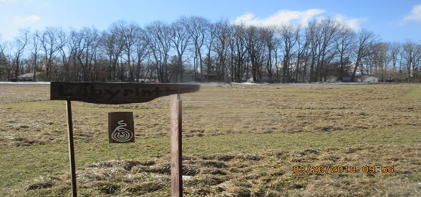
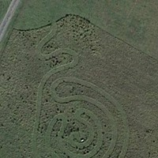
Garden of prayer
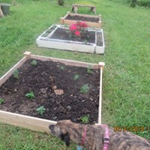

Walking trails
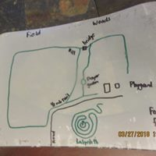
One ½ mile loop,
one 1/3 mile loop,
all interconnected
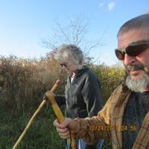

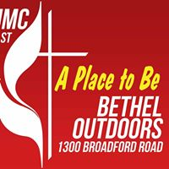
Special events
July
fifth Sunday worship 10am
Bible study on the disciples Thursday starts June 15 10 am with lunch after
Pet blessing 1st Sunday in Oct. 2pm

See us on facebook @ facebook.com/Betheloutdoors/

Stations of the cross
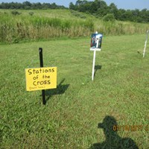
Book nook in pavilion with devotionals and guides for labyrinth and stations
