Your Support Touches Many Lives in Many Special Ways!  
Hospice of Garrett County, Inc. provides total in-home or home-like care for terminally ill patients with six months of less to live if the disease follows its normal progression.

Hospice provides home health care, nurses social workers, volunteer caregivers, dietary counseling, medical supplies, equipment, medications, and short-term or respite care as needed at no cost to the patient of family.

Following a patient’s death, Hospice of Garrett County provides bereavement services and support to family members and caregivers for up to 13 months.

Your support and contributions help us offer these services throughout Garrett County. Your help is greatly appreciated.

Thank You!

P.O. Box 271 Oakland, MD 21550

301.334.5151

djbrenneman1@gmail.com



*(Parent/Guardian must sign if participant is under age 18)*

How to Participate  
Walkers will meet on Sunday, June 19 at 2PM. RAIN OR SHINE. Donations received will be collected on the day of the walk. Walkers will have the choice of walking route lengths, ranked from beginner to intermediate.

Prizes   
Prizes awarded to those who have raised and turned in the most donations by the day of the walk:   
Most Donations Raised:   
$800.00 in Prizes!  
Second Highest In Donations Raised:   
$200.00 in Prizes!

Special Drawings for extra prizes for all participants and a shirt for each walker who brings in $50.00 in donations.

Waiver of Responsibility  
As a willing participant in “Walk for Hospice”, I hereby release Hospice of Garrett County, Inc., its Board of Directors and Officers, Employees and Agents, as well as all other persons and entitles sponsoring or participating in this event, The Town of Oakland, The Glades Town Park, from all liability or other claims or demands for damages arising directly or indirectly out of my participation, or that of my child, or any child for which I am responsible. I consent for emergency medical treatment or first aid for myself or any child if the same is responsibly necessary.  
  
  
Signature: ______________________________________

Date: _________________________________________

27th

Annual

**WALK**

**ANNIVERSARY**

FOR

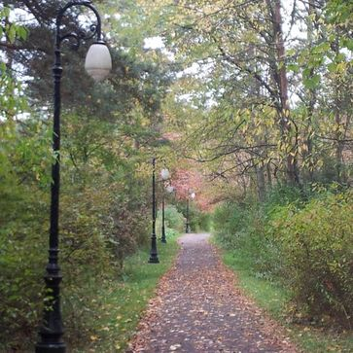  
**Sunday**

**June 19, 2022**

**2PM**

Held at: The Glades Town Park

10 Spruce Ln   
Oakland, MD 21550

Food, Raffles & Celebration of Life

***Walker/Fundraiser Collection Form***

Last Name: ___________________________________First:____________________________________________MI:______

Home Address: _________________________________________________________City/Town: ____________________

State:_______ Zip: ______________________ Home Phone: ___________________________________________________

Employer/School/Organization: __________________________________________________________________________

**Sponsors, please give your donation when you sign up.**

**(Make sure checks payable to Hospice of Garrett County, Inc.)**

|  |  |  |  |  |  |  |
| --- | --- | --- | --- | --- | --- | --- |
| Name | Address | $500 | $100 | $50 | $20 | other |
|  |  |  |  |  |  |  |
|  |  |  |  |  |  |  |
|  |  |  |  |  |  |  |
|  |  |  |  |  |  |  |
|  |  |  |  |  |  |  |
|  |  |  |  |  |  |  |
|  |  |  |  |  |  |  |
|  |  |  |  |  |  |  |
|  |  |  |  |  |  |  |
|  |  |  |  |  |  |  |
|  |  |  |  |  |  |  |
|  |  |  |  |  |  |  |
|  |  |  |  |  |  |  |
|  |  |  |  |  |  |  |
|  |  |  |  |  |  |  |
|  |  |  |  |  |  |  |
|  |  |  |  |  |  |  |
|  |  |  |  |  |  |  |
|  |  |  |  |  |  |  |
|  |  |  |  |  |  |  |