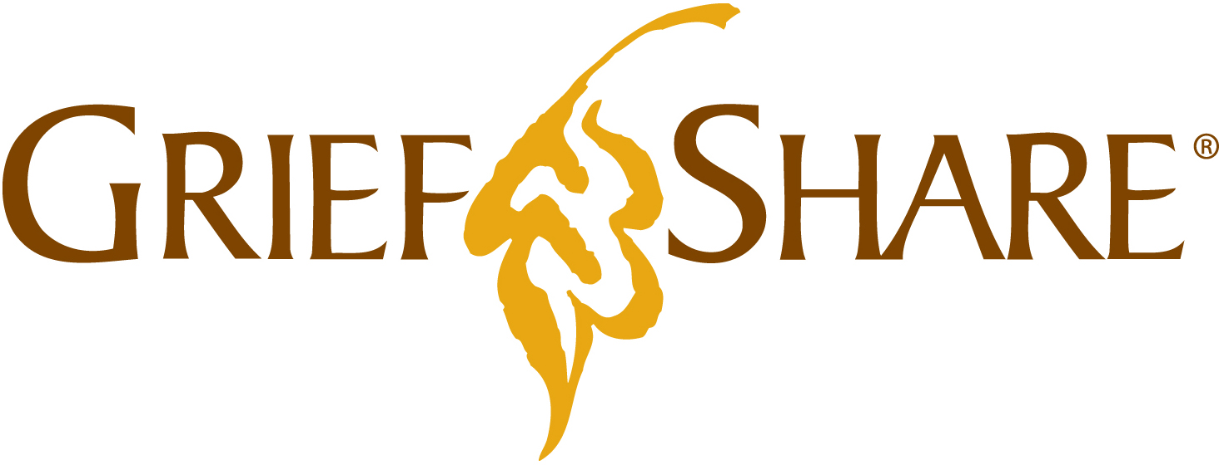

**GriefShare is a special weekly faith based seminar/support group for people grieving the death of someone close. It’s a place where you can be around people who understand how you feel and the pain of your loss. At GriefShare, you’ll learn valuable information that will help you through this difficult time in your life.**

***We know it hurts, and***

***we want to help.***

**Classes will be held on Tuesday evenings at 5:00 p.m. beginning Tuesday, May 3, 2022. We will meet as a group at the Hospice Office in Oakland, view the video together, and then join with others for a time of group discussion. A light meal will be served.**

***Pre-registration requested.***

***Please call the Hospice Office at 301-334-5151***

***ASAP to make sure we have enough workbooks.***

**There is no cost for the class and the workbooks are generously paid for by**

**C & S Fredlock Funeral Home.**

**Sponsored by HOSPICE OF GARRETT COUNTY**

**in coordination with LOCH LYNN CHURCH OF GOD**